Lab 8.2 Host Docker on Kubernetes cluster

This section will show you how to ost Asp .Net application on Kubernetes Cluster

This lab has 2 sub-sections:

8.2.1 Clone Docker repo on build server and prepare docker image

8.2.2 Host built docker image on Kubernetes Cluster

**Step 8.2.1:** Clone Docker repo on build server and prepare docker image.

git clone <https://github.com/SimplilearnDevOpsOfficial/DockerWithkubernetes.git>

cd Docker

docker build –t dockerapp .

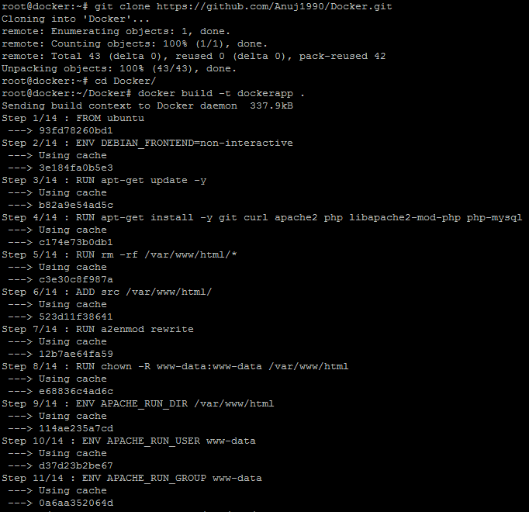

Once the build is successful, execute the command below to check on the Docker file.

docker images | grep dockerapp

Check if any of the pods are running in the cluster by executing the command mentioned below:

kubectl get pods

Run the Docker app by executing the command below:

kubectl run dockerapp –image=dockerapp –port=80 --image-pull-policy=Never

kubectl expose deployment/dockerapp –port=80 –target-port=80 –type=NodePort

kubectl get pods

**Step 8.2.2:** Host built docker image on Kubernetes Cluster.

Check if the “**dockerapp**” is running as a service by executing the command mentioned below:

kubectl get services

Check if the “**dockerapp**”is deployed by executing the command mentioned below:

kubectl get deployments

You should be able to see the output mentioned in the screenshot.

